MTO 6.1 Examples: Perry, Review of Forte
(Note: audio, video, and other interactive examples are only available online)
http://www.mtosmt.org/issues/mto.00.6.1/mto.00.6.1.perry.php
Example 1.
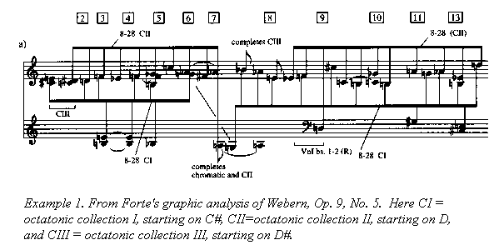

Example 2.
