MTO 8.4 Examples: Holm-Hudson, Your Guitar, It Sounds So Sweet and Clear
(Note: audio, video, and other interactive examples are only available online)
http://www.mtosmt.org/issues/mto.02.8.4/mto.02.8.4.holm-hudson.php

Example 4. Transcription of the introduction to the Carpenters’ “Superstar,” with annotated sign-functions after Tagg (2000)
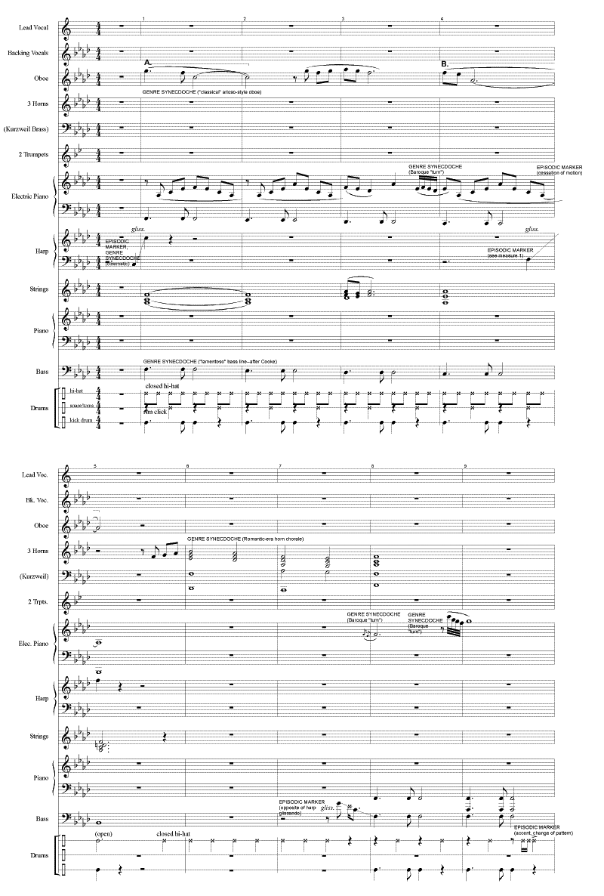
Example 5. Transcription of the introduction to the Carpenters’ “Superstar,” with annotated sign-functions after Tagg (2000)
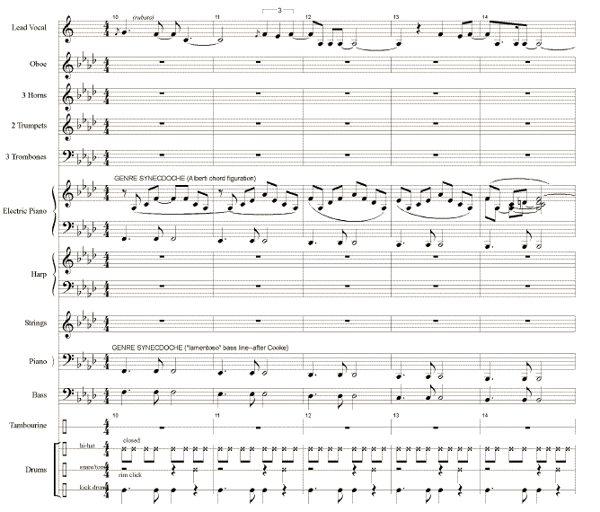
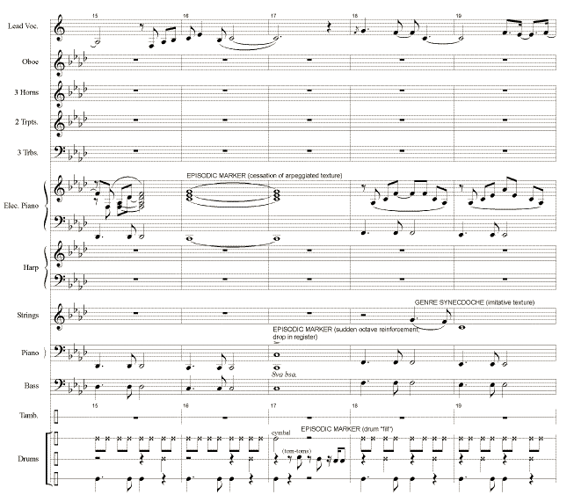
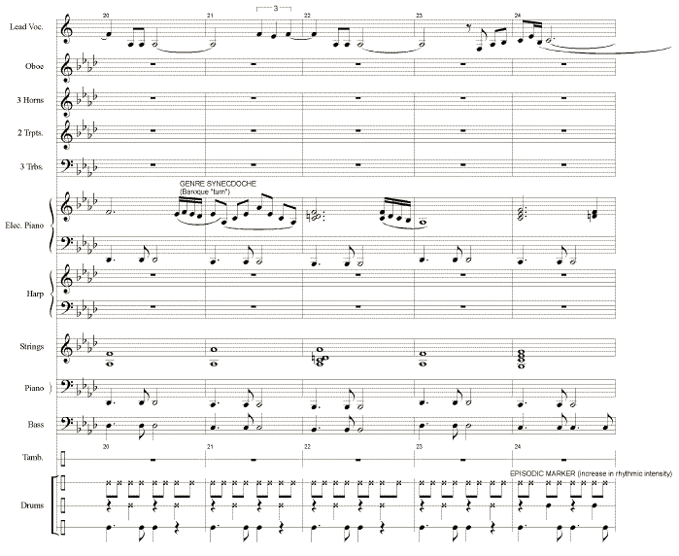
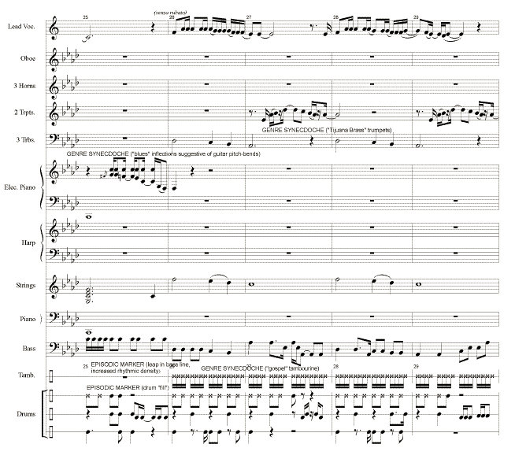
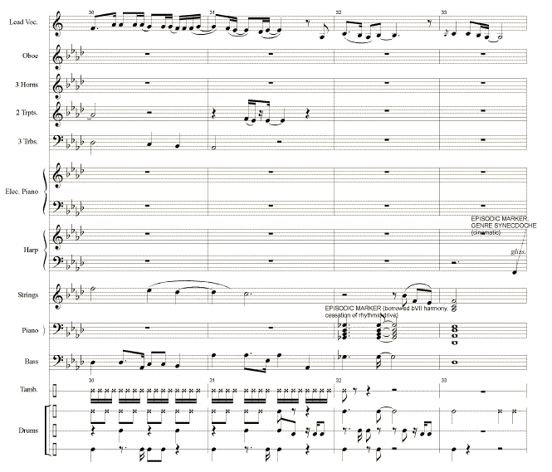

Example 16. The “semantic range” of the introduction to the Carpenters’ “Superstar”
