MTO 8.4 Examples: Väisälä, Review of Jackson and Murtomäki
(Note: audio, video, and other interactive examples are only available online)
http://www.mtosmt.org/issues/mto.02.8.4/mto.02.8.4.väisälä.php
Example 1.
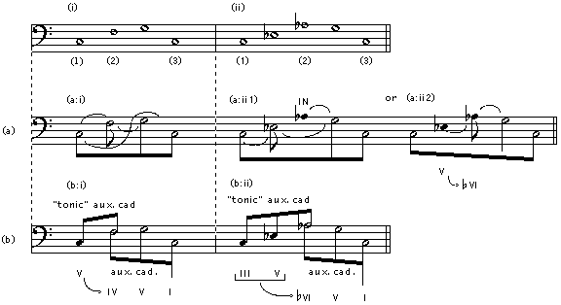

Example 2.
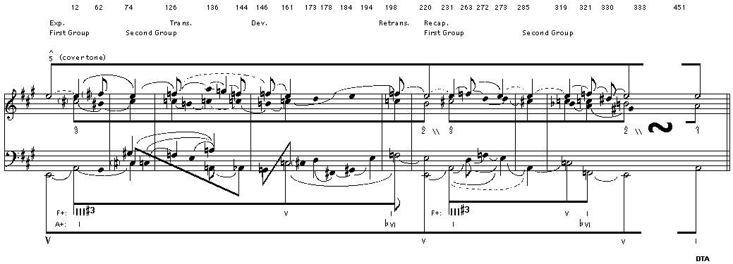
Example 3.
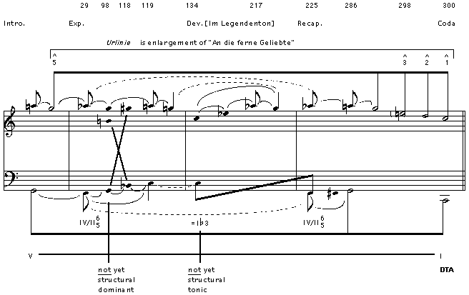

Example 4.
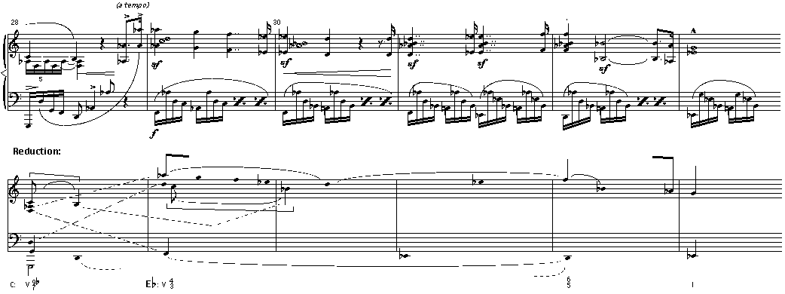
Example 5.
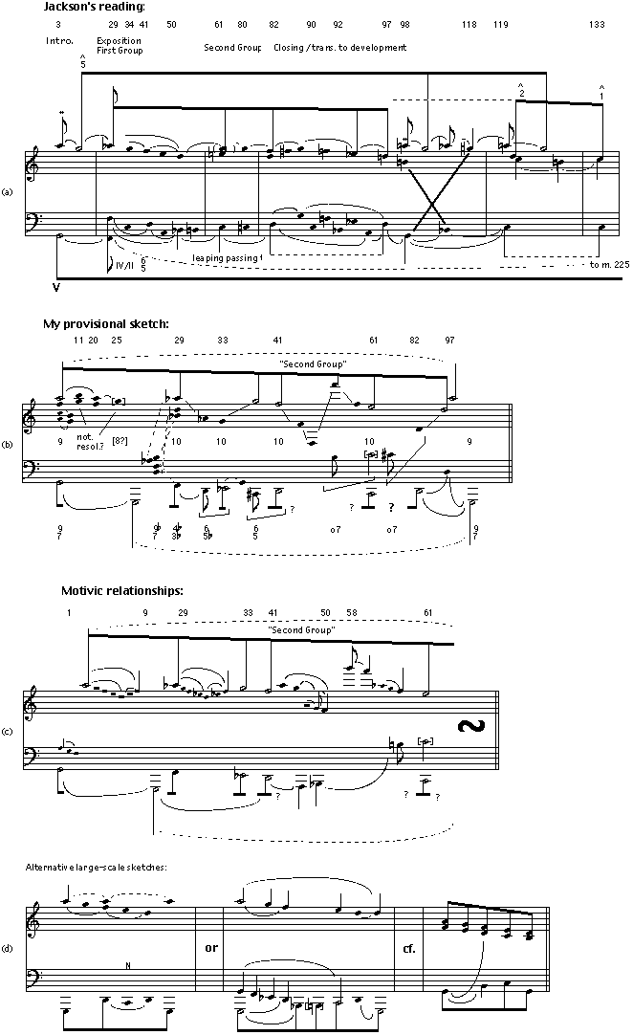
Example 6.
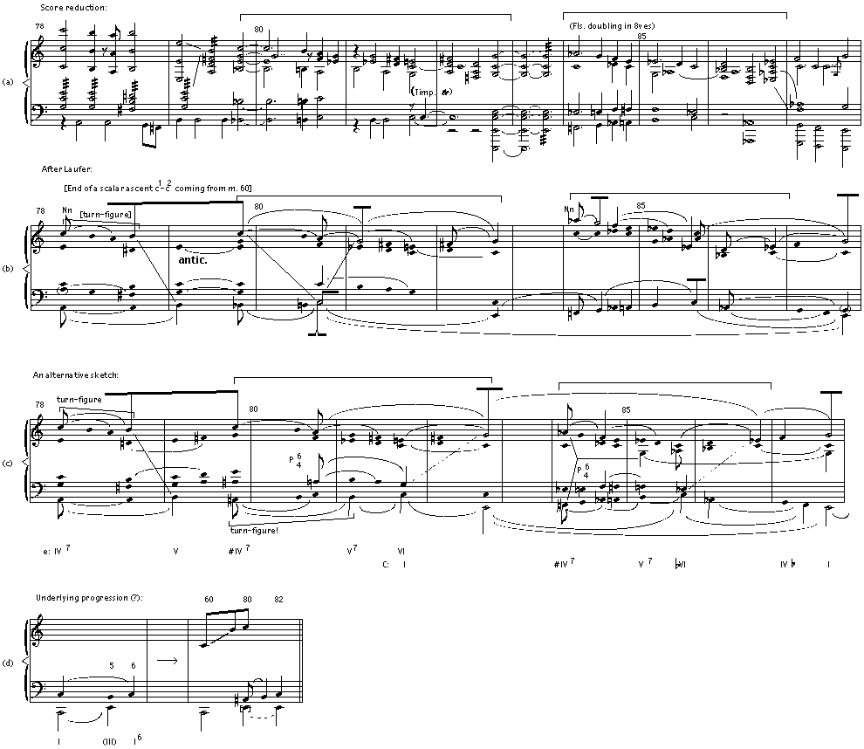

Example 7.
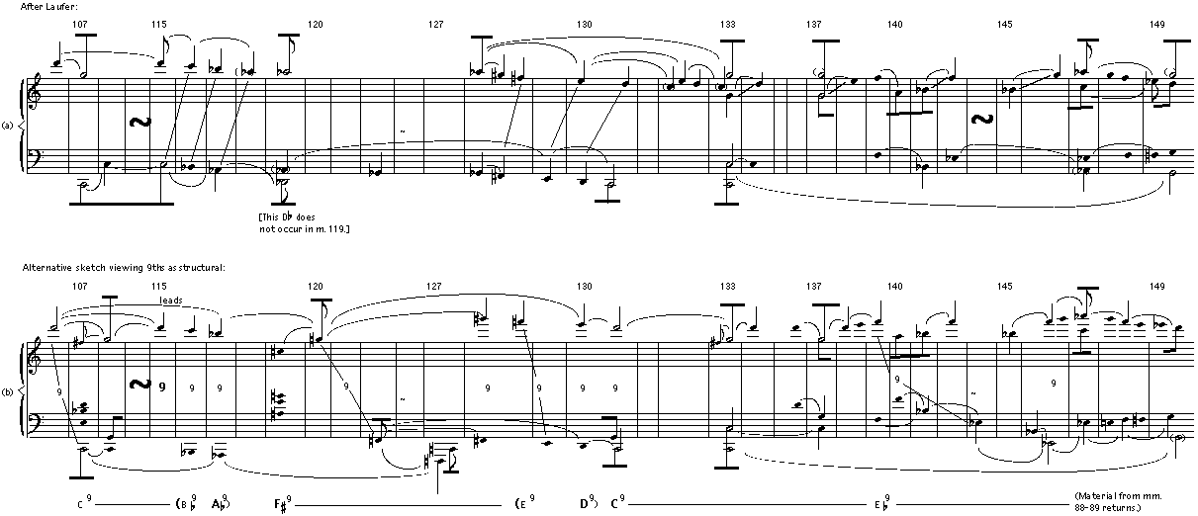
Example 8.
