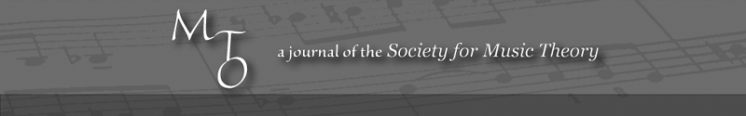
MTO 10.1 Examples: Bass, Review of David Kopp, Chromatic Transformations in Nineteenth-Century Music
(Note: audio, video, and other interactive examples are only available online)
http://www.mtosmt.org/issues/mto.04.10.1/mto.04.10.1.bass.php
Table 1. Kopp’s Triadic Transformation Types
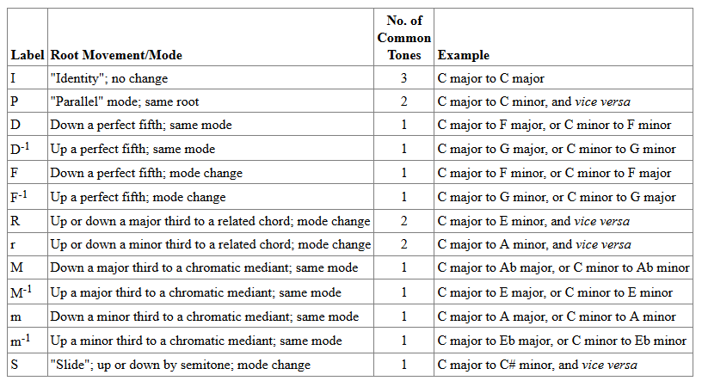

Example 1. Common-tone augmented sixth and diminished seventh chords
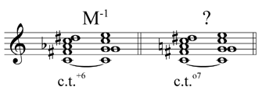
Example 2. Melodic-harmonic cross-references in Schubert’s Die junge Nonne
