MTO 13.2 Examples: Buchler, Reconsidering Klumpenhouwer Networks
(Note: audio, video, and other interactive examples are only available online)
http://www.mtosmt.org/issues/mto.07.13.2/mto.07.13.2.buchler.php
Figure 1. A network of nodes and arrows
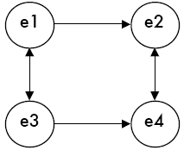
Figure 2. An abstract four-node K-net model
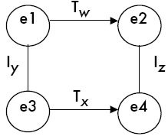
Figure 3. An abstract four-node T-net
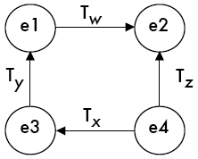
Figure 4. Two four-node I-nets (that are really K-nets)
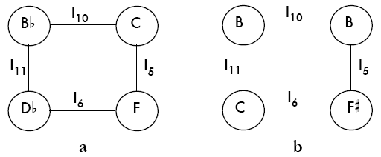
but implicitly:
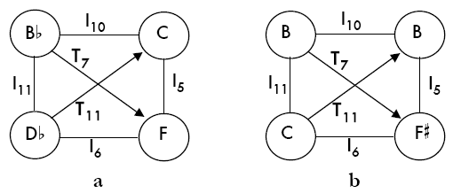
and more clearly:
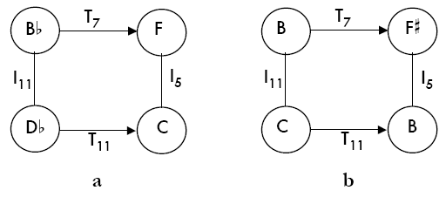

Figure 5. Two ways to calculate K-net positive isography
a)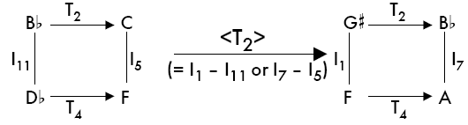
b) 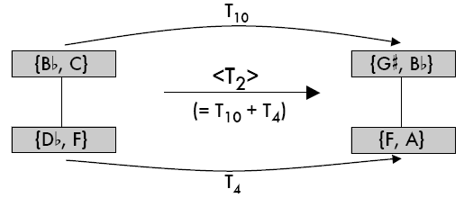
5a shows the regular way to arrive at <T₂>; 5b reconfigures the pair,
demonstrating the dual transformational path to <T₂>

Figure 6. Two ways to calculate K-net negative isography
a)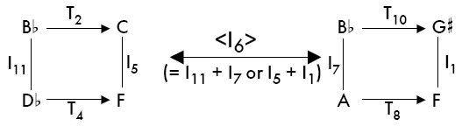
b) 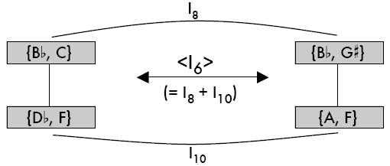

Figure 7. Lewin’s rather large K-net (Figure 1.3 from Lewin 2002)
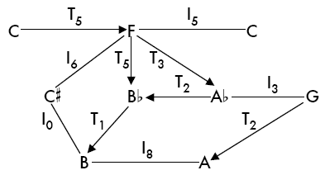

Figure 8. One T-set that falls out of Lewin’s rather large K-net
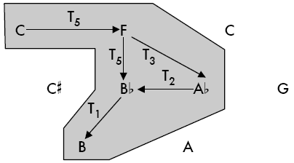

Figure 9. The other T-set that (less obviously) falls out of Lewin’s rather large K-net
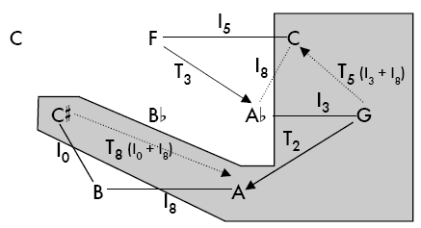
(dotted lines signify relationships that are implicit from Lewin’s arrows)

Figure 10. Two simpler displays that more clearly differentiate the two constituent T-sets
a) | b)
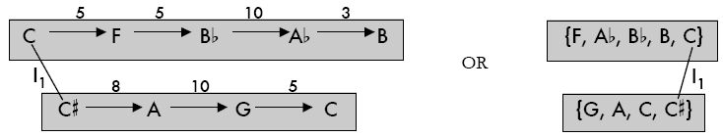

Figure 11. Two abstractions, representing all possible K-nets that are positively isographic to Lewin’s rather large K-net
a) | b)

Figure 12. Two progressions that feature <T₀> relations
a) 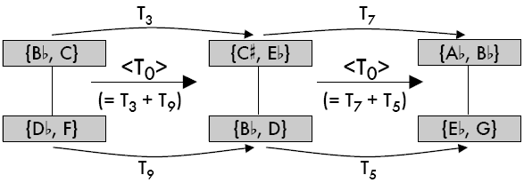
b) 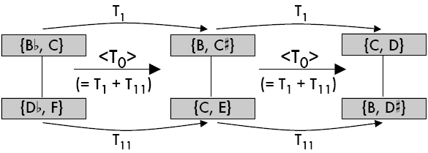

Figure 13. Two progressions that feature <T₂> relations
a) 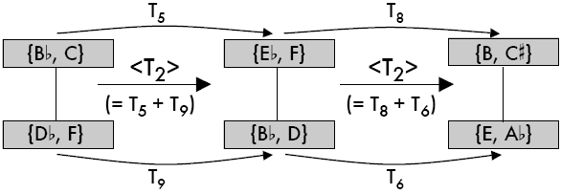
b) 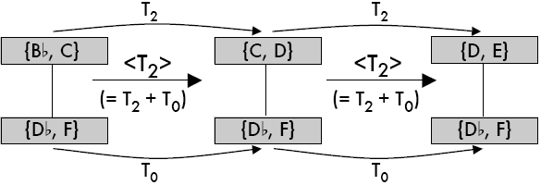

Figure 14. Lutoslawski, Symphony No. 4, Rehearsal 92, vc. (tutti)
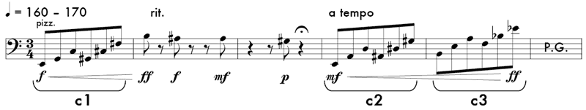

Figure 15. K-net interpretations of the passage from Figure 14
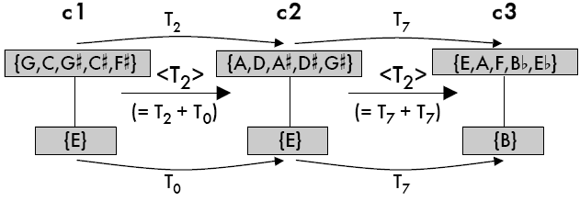

Figure 16. Trichordal and dyadic set classes that cannot be strong, positively, or negatively isographic with each other
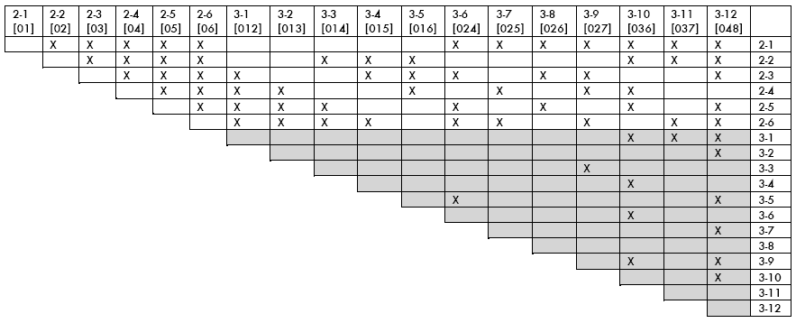
(the shaded region duplicates Stoecker 2002, Example 2)

Figure 17. Two four-node K-net types (box and umbrella)
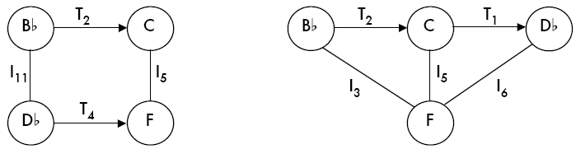

Figure 18. Dizzy Gillespie, “A Night in Tunisia,” opening gesture split into two four-note segments
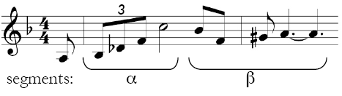

Figure 19. Three ways to split α 4-14 {B,C,D,F}([0237]) and β 4-4 {F,G,A,B}([0125]) into the same pairs of constituent set classes
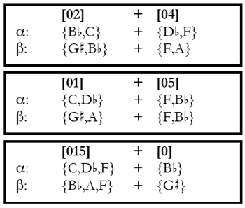
Figure 20. {B,C,D,F} and β {F,G,A,B} cast as five isographic pairs of K-nets
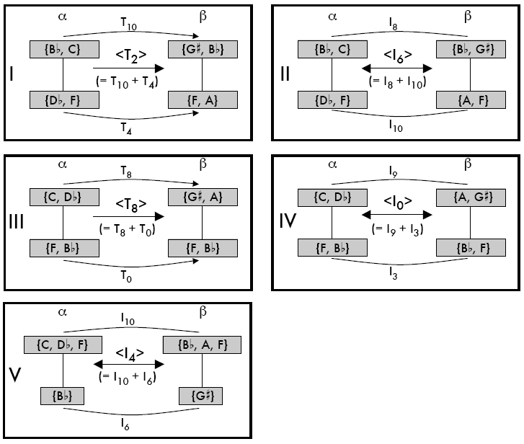

Figure 21. The opening twelve notes of Webern, opus 23, mvt. 3, segmented into trichords
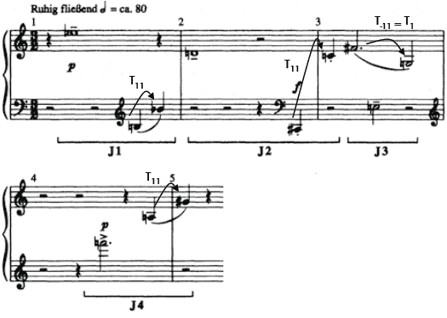

Figure 22. Six network interpretations of the first trichord (J1 in Figure 20)
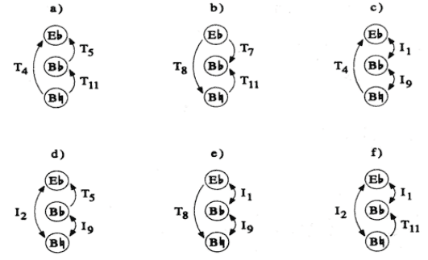

Figure 23. One depiction of positive isography among the trichords J1–J4
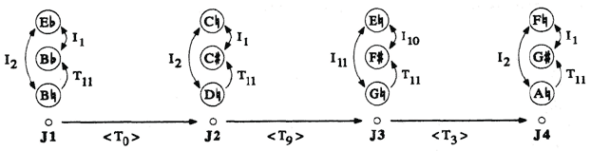

Figure 24. An example of K-nets that are consistently projected in register
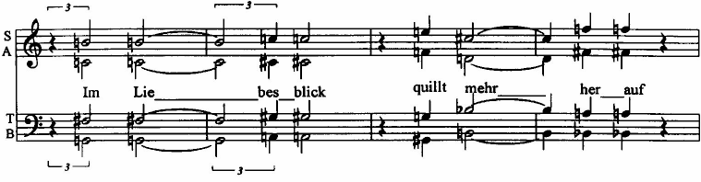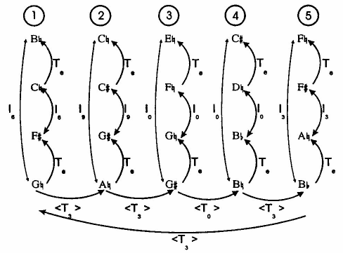

Figure 25. Four isographic K-nets (g1′, g2′, g3, g4) combine to form a “hyper-network” or “middleground” K-net structure
a) Schoenberg, op. 11, no. 2, four chords excerpted from Lewin's Ex. 9
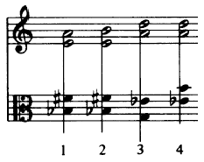
b) Four network interpretations excerpted from Lewin's Ex. 10
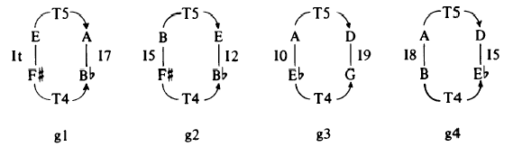
c) Lewin's Ex. 12: interpretations g1 and g2 and their negatively isographic permutations g1' and g2'
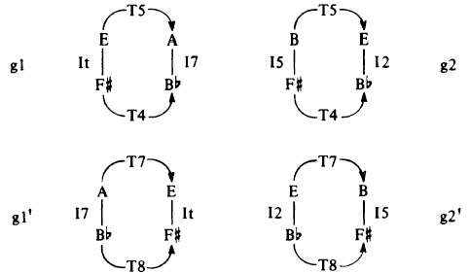

d) Network that (recursively) interprets g1', g2', g3, g4, based upon Lewin's Ex. 13
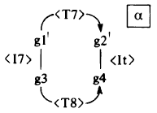

Figure 26. K-nets intended to reflect the musical surface shown in Figure 25a
