MTO 13.2 Examples: Sauer, Cognitive Dissonance and the Performer’s Inner Conflict
(Note: audio, video, and other interactive examples are only available online)
http://www.mtosmt.org/issues/mto.07.13.2/mto.07.13.2.sauer.php
Example 1. Beethoven, Op. 101 (i), measures 1–35
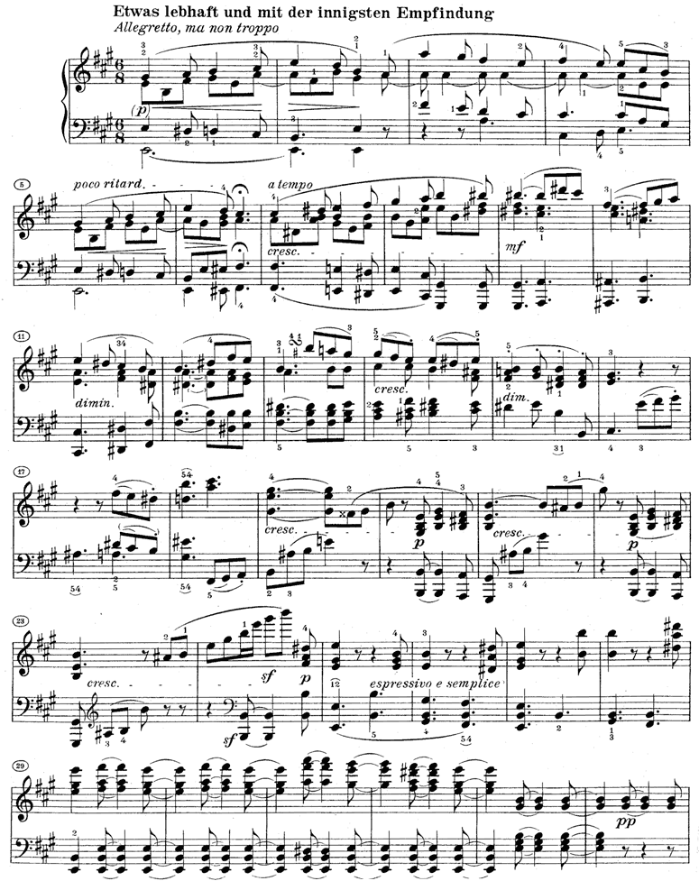

Example 2. Mozart, K. 331 (i), measures 1–18
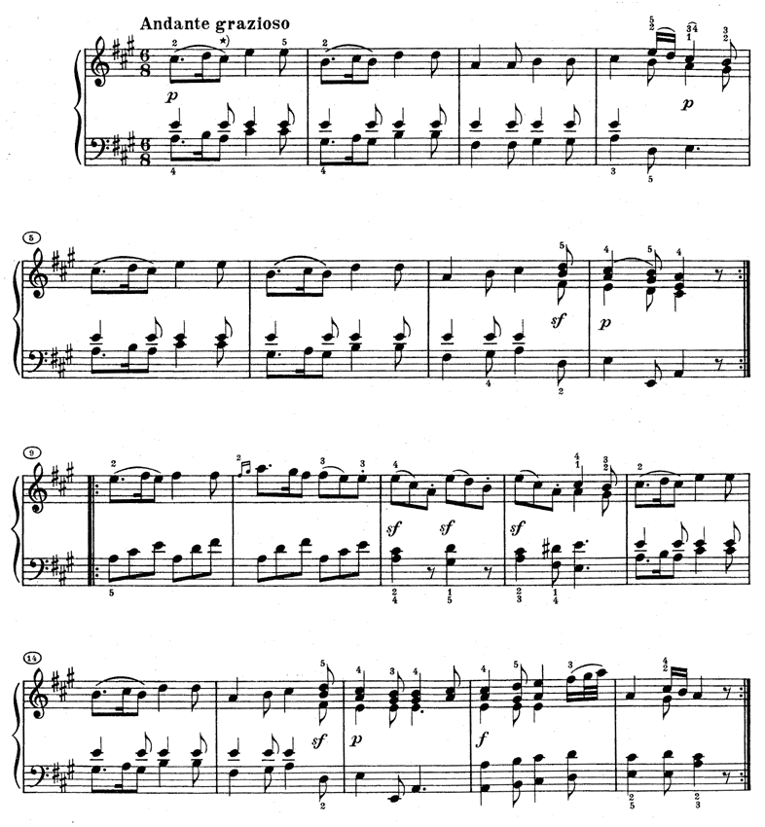

Example 3. Beethoven, Op. 28 (i), measures 1–39
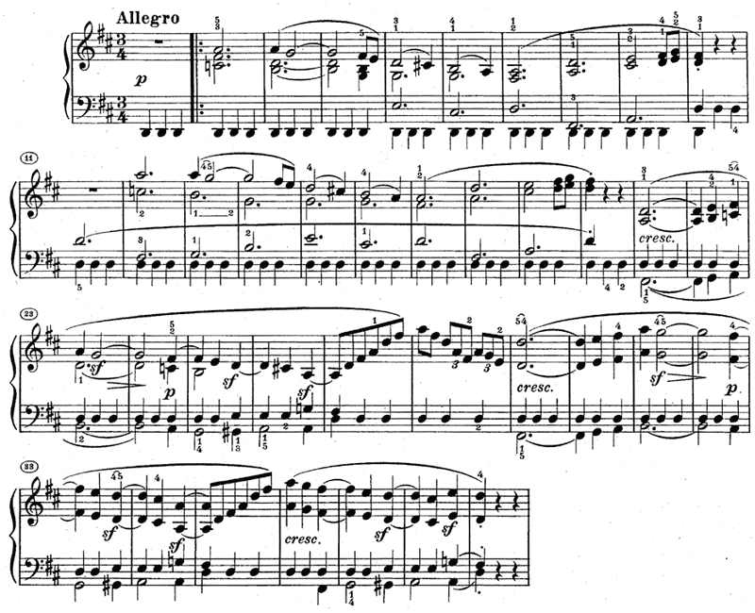

Example 4. Beethoven, Op. 101 (i), measures 1–35, with altered dynamic markings in measures 24–28
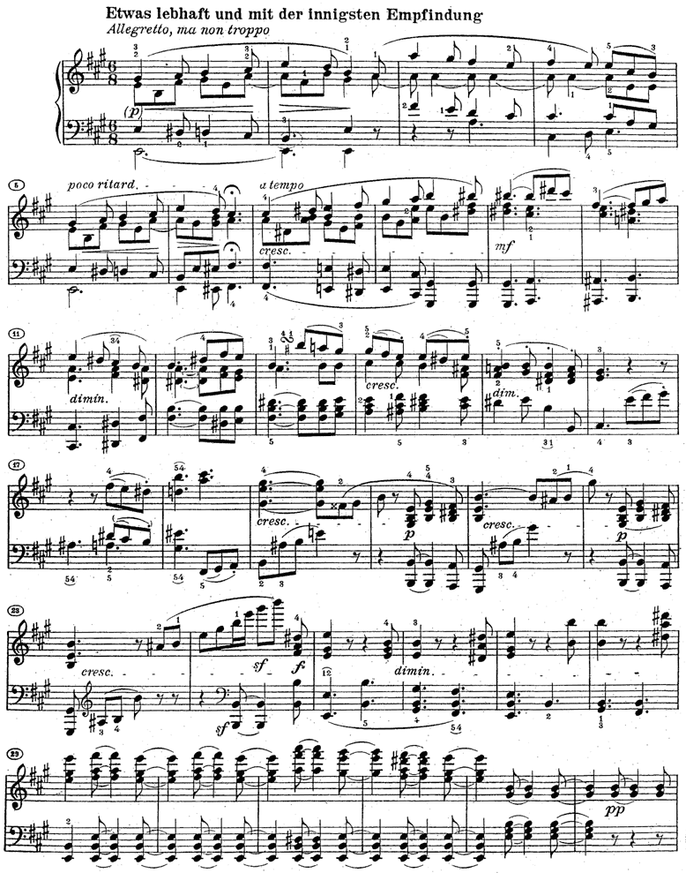
Example 5. Chopin, Barcarolle, Op. 60, measures 4–20
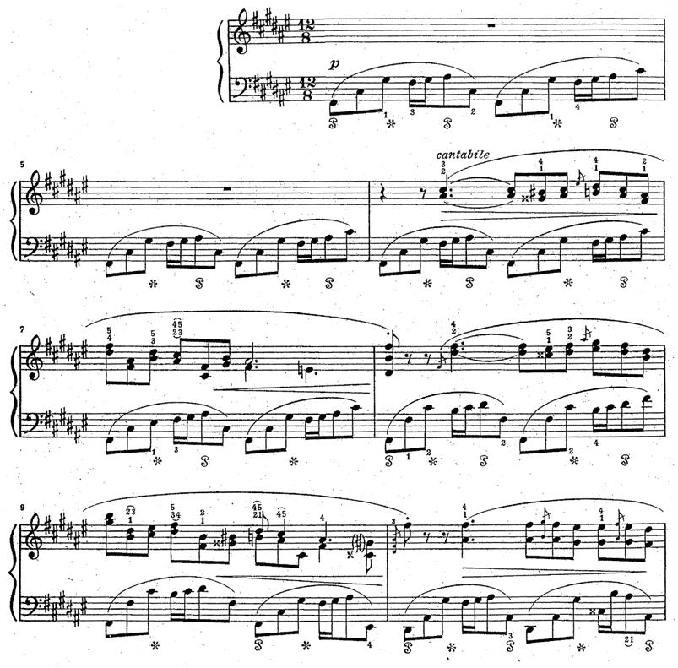
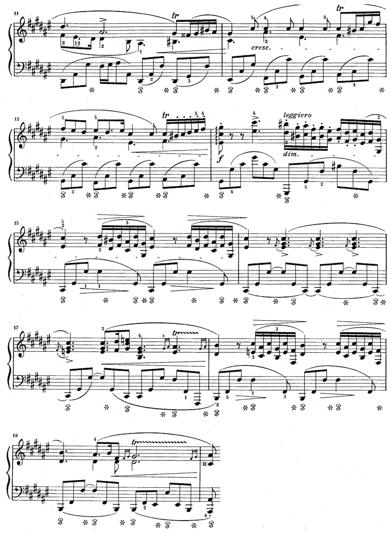
Example 6. Schubert, D. 960 (i), measures –8
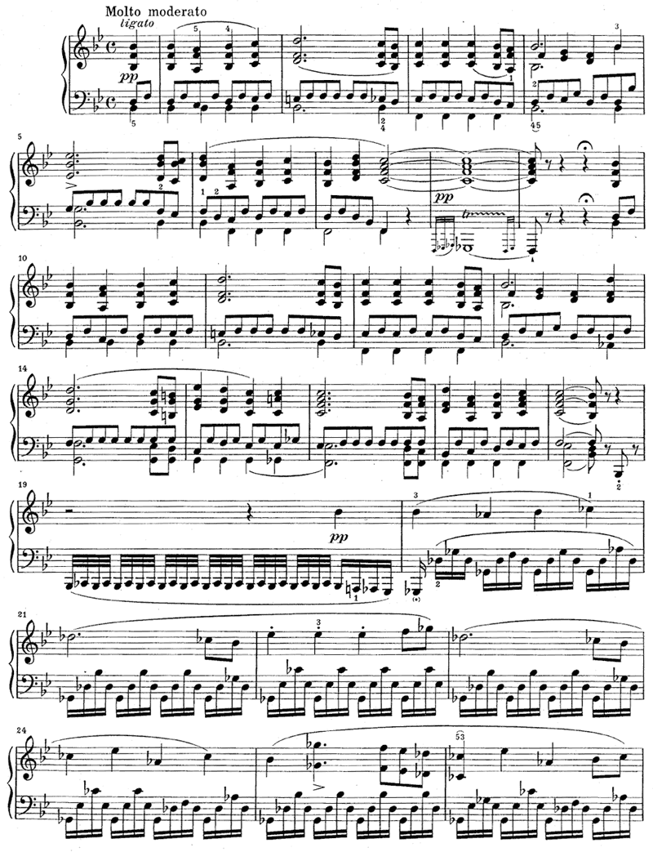
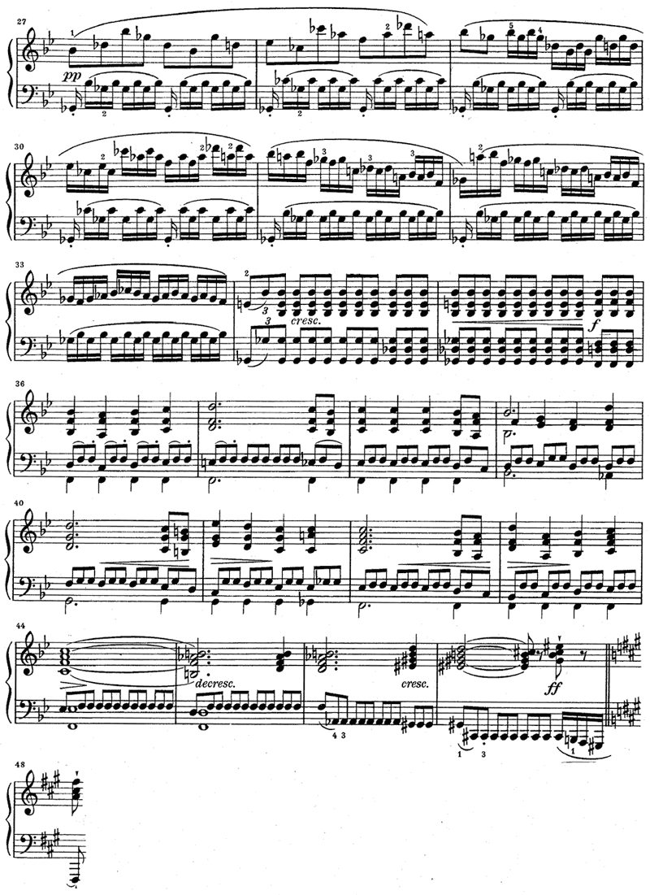
Example 7. Beethoven, Op. 101 (i), measures 98–102
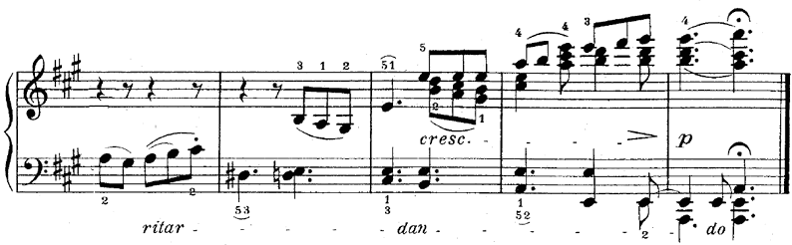

Example 8. Beethoven, Op. 101 (ii), measures 44–54
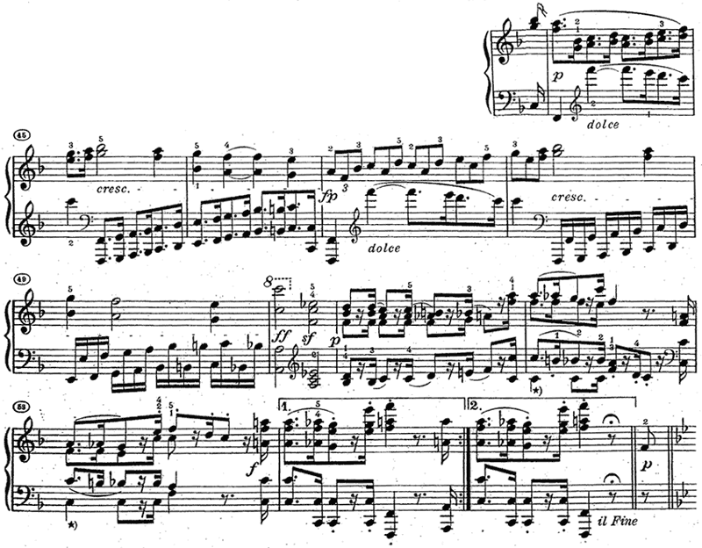

Example 9. Beethoven, Op. 101, transition to finale, measures 21–33
