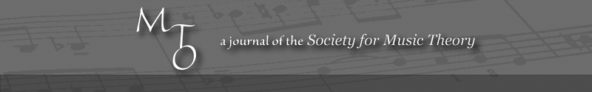
MTO 13.3 Examples: Sallmen, Listening to the Music Itself
(Note: audio, video, and other interactive examples are only available online)
http://www.mtosmt.org/issues/mto.07.13.3/mto.07.13.3.sallmen.php
Example 1. Robert Lowell, “In Genesis” from History (1973) in Collected Poems / Robert Lowell, ed. Frank Bidart & David Gewanter (New York: Farrar, Strauss and Giroux, 2003), 423
A1 | Blank. A camel blotting up the water.
A2 | God with whom nothing is design or intention.  In the beginning the Sabbath could last a week,  God grumbling secrecies behind Blue Hill . . .
B1 | The serpent walked on foot like us in Eden;  glorified by the perfect Northern exposure,  Eve and Adam knew their nakedness,  a discovery to be repeated many times . . .
B2 | in joyless stupor?. . . Orpheus in Genesis  hacked words from brute sound, and taught men English,  plucked all the flowers, deflowered all the girls  with the overemphasis of a father.
C | He used too many words, his sons killed him,  dancing with grateful gaiety round the cookout.
“In Genesis” from COLLECTED POEMS by Robert Lowell.
Copyright © 2003 by Harriet and Sheridan Lowell.
Reprinted by permission of Farrar, Straus and Giroux, LLC.

Example 2. X, pitches of Section A1 vocal line
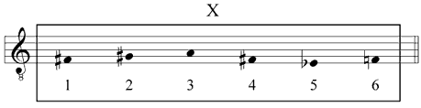

Example 3. Overview of analysis
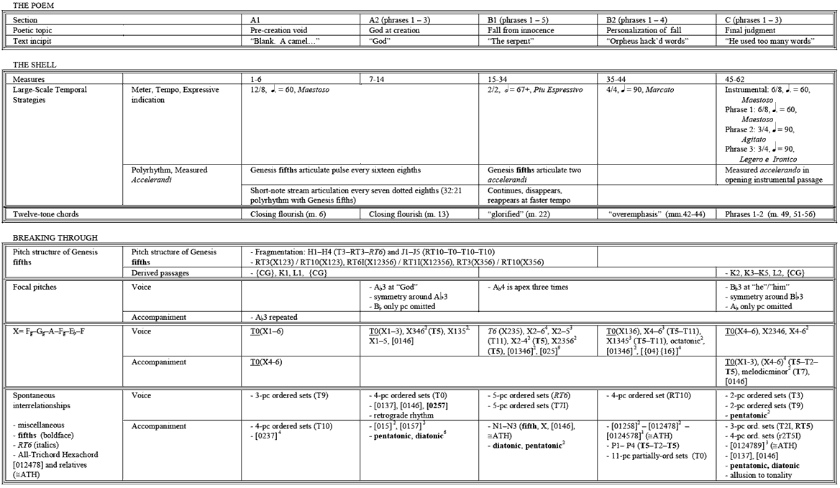
Example 4. Overall Form of Elliott Carter’s “In Genesis”
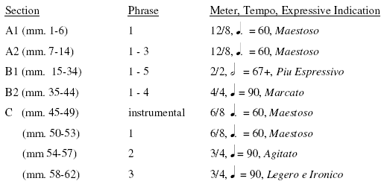

Example 5. Rhythmic features of the Genesis fifths
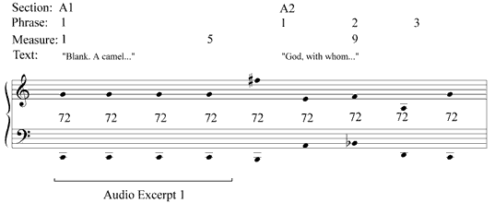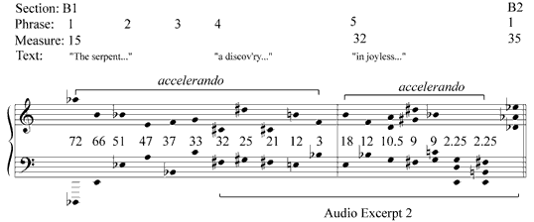

Example 6. RT6-invariant, all-interval twelve-tone chords
N.B. Brackets connect T₆-related pitch classes
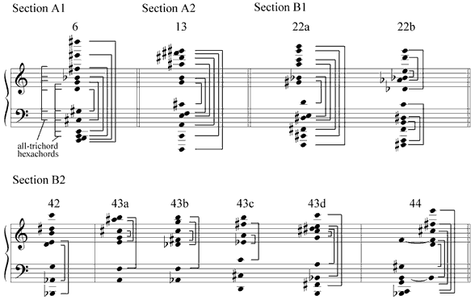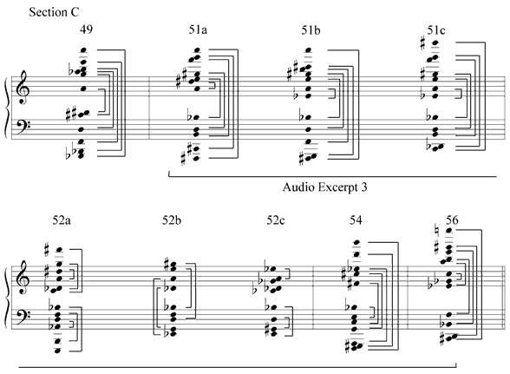

Example 7. Pitch structure in the Genesis fifths
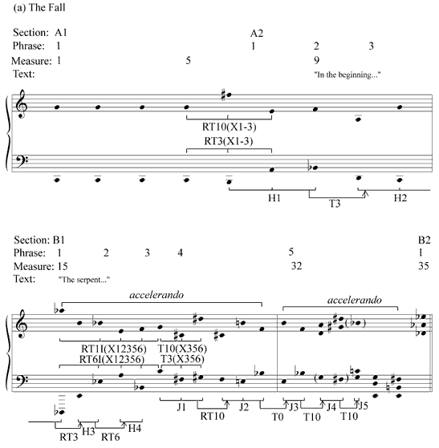
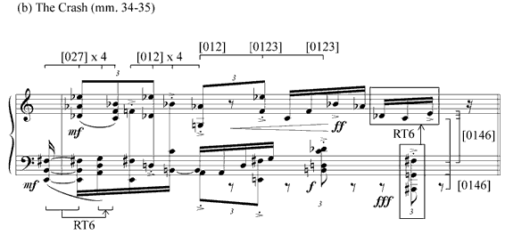
© Copyright 1982 by Hendon Music, Inc. A Boosey & Hawkes Company Reprinted by permission
Example 8. Fifth-based passages in Section C derived from Section A
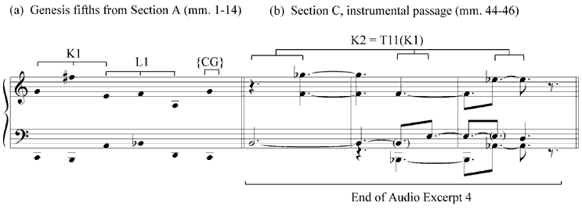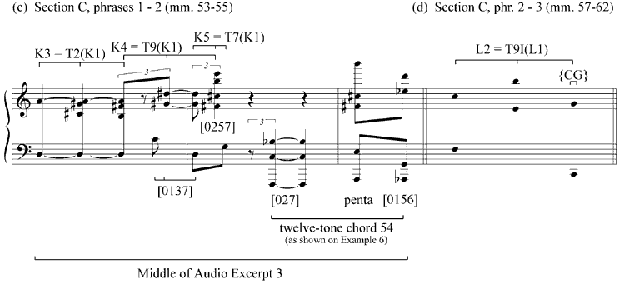© Copyright 1982 by Hendon Music, Inc. A Boosey & Hawkes Company Reprinted by permission
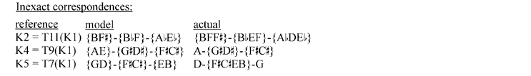

Example 9. Focal pitches and the divinity/humanity dichotomy
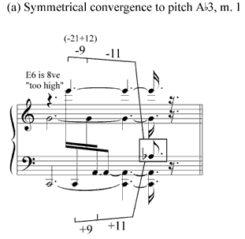
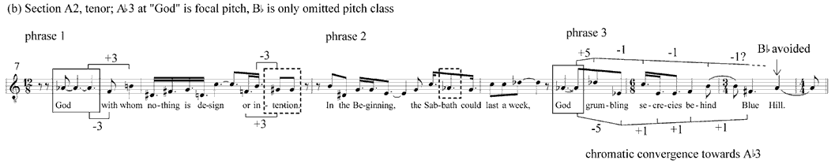
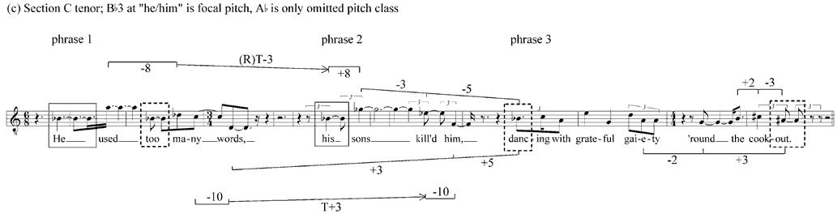
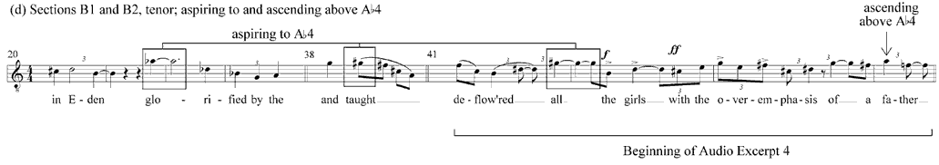© Copyright 1982 by Hendon Music, Inc. A Boosey & Hawkes Company Reprinted by permission

Example 10. X and spontaneous interrelationships in Section A1
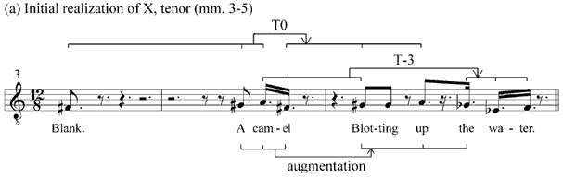
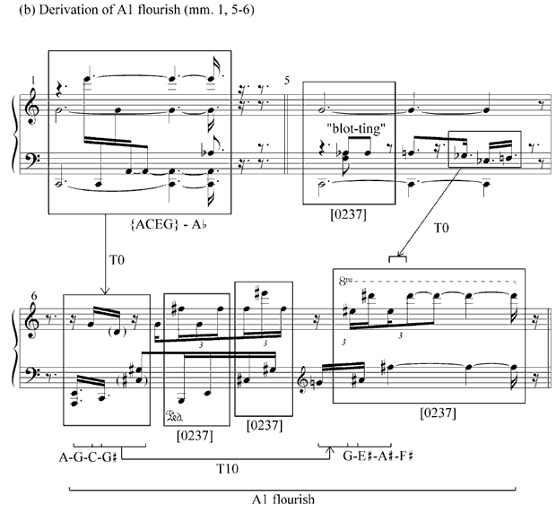
© Copyright 1982 by Hendon Music, Inc. A Boosey & Hawkes Company Reprinted by permission

Example 11. X and spontaneous interrelationships in Section A2, phrase 1 (mm. 7–8)
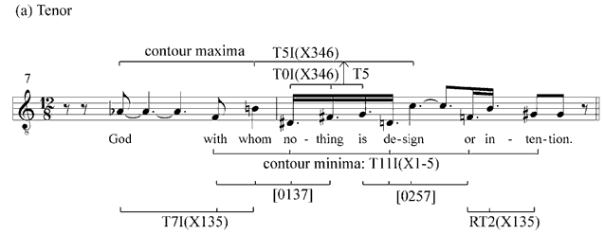
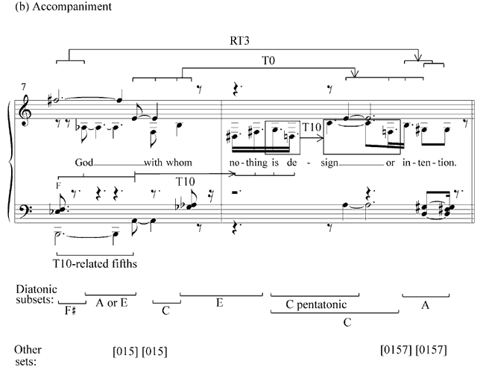
© Copyright 1982 by Hendon Music, Inc. A Boosey & Hawkes Company Reprinted by permission

Example 12. X and spontaneous interrelationships in Section A2, tenor (mm. 7–13)
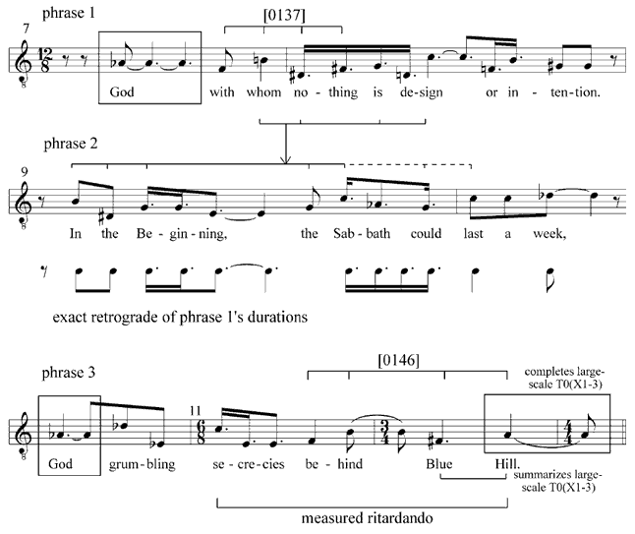
© Copyright 1982 by Hendon Music, Inc. A Boosey & Hawkes Company Reprinted by permission

Example 13. X and spontaneous interrelationships in Section B1, tenor (mm. 15–33)
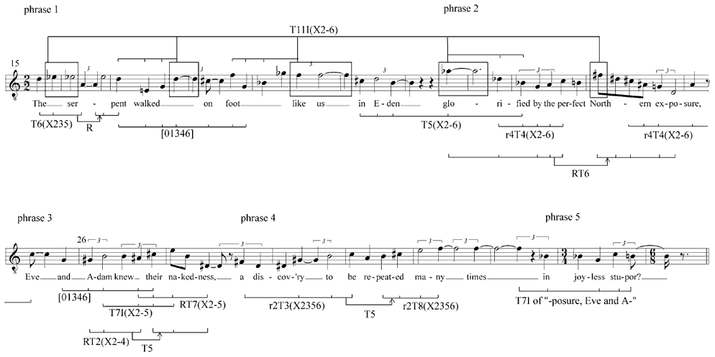
© Copyright 1982 by Hendon Music, Inc. A Boosey & Hawkes Company Reprinted by permission
Example 14. Section B1, phrase 2 (mm. 23–25)
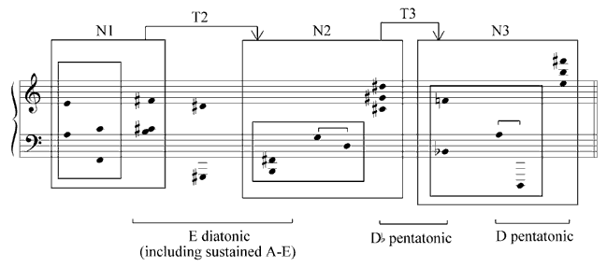

Example 15. Section B2, tenor (mm. 36–44)
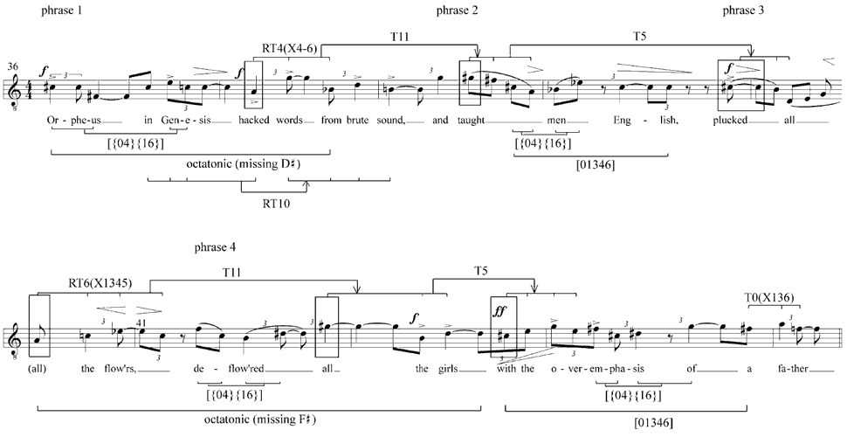
© Copyright 1982 by Hendon Music, Inc. A Boosey & Hawkes Company Reprinted by permission
Example 16. Section B2, phrases 1 and 2 (mm. 36–9)
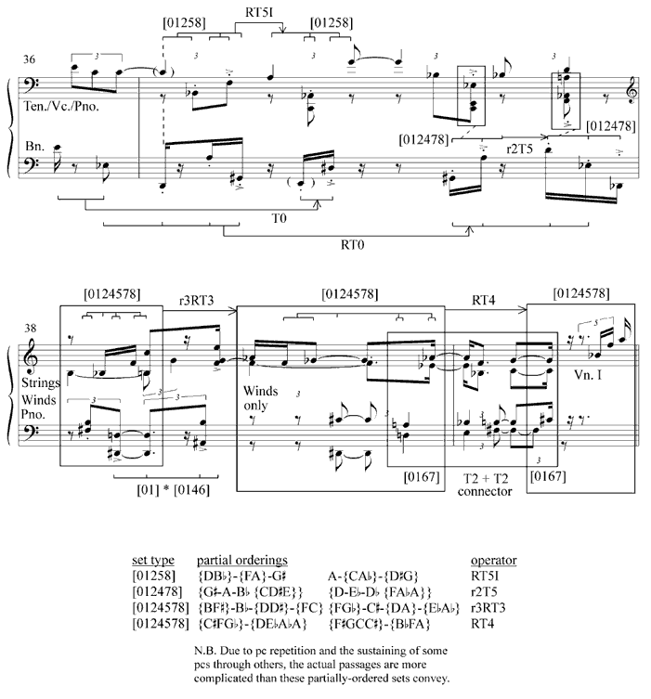
© Copyright 1982 by Hendon Music, Inc. A Boosey & Hawkes Company Reprinted by permission

Example 17. Section B2, phrases 1–3, accompaniment
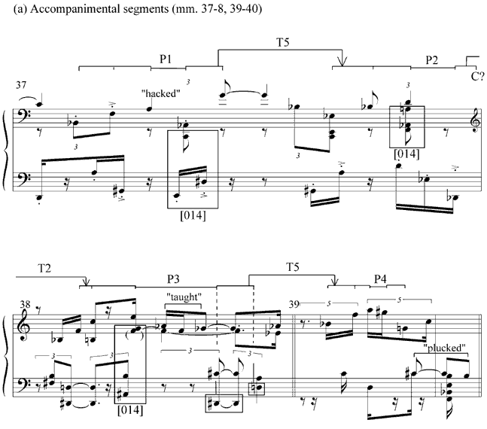
© Copyright 1982 by Hendon Music, Inc. A Boosey & Hawkes Company Reprinted by permission
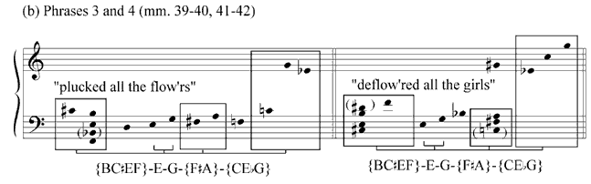

Example 18. Section C, tenor
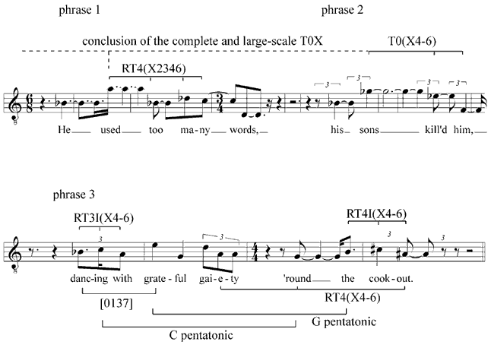
© Copyright 1982 by Hendon Music, Inc. A Boosey & Hawkes Company Reprinted by permission

Example 19. Section C, phrase 3
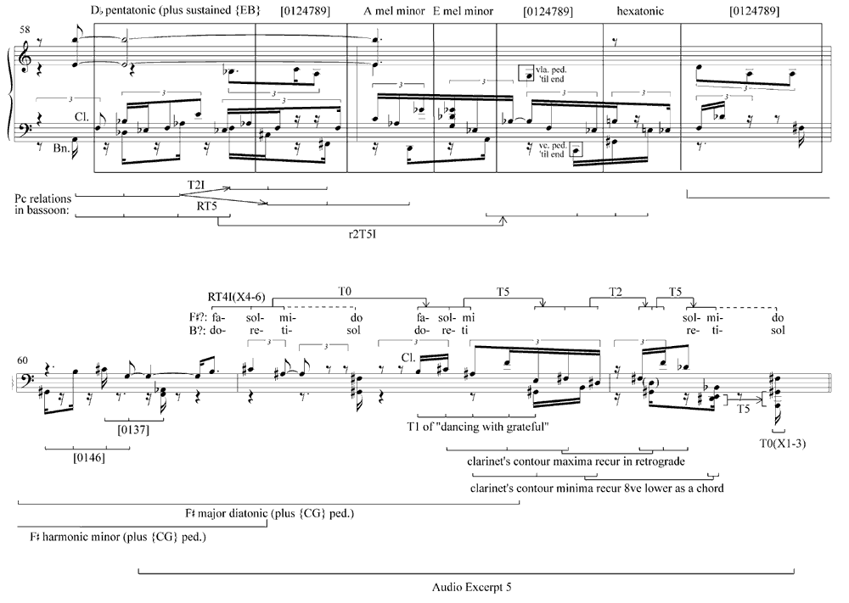
© Copyright 1982 by Hendon Music, Inc. A Boosey & Hawkes Company Reprinted by permission

