MTO 23.3 Examples: Bungert, A Tale of Three Schenkers
(Note: audio, video, and other interactive examples are only available online)
http://www.mtosmt.org/issues/mto.17.23.3/mto.17.23.3.bungert.php
Example 1. Chopin Berceuse in D major op. 57, mm. 3–7.1
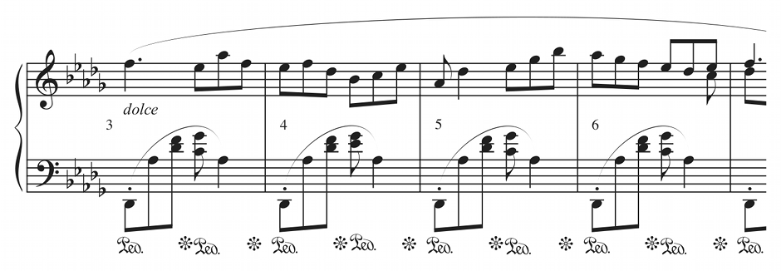

Example 2. “Fortsetzung der Urlinie-Betrachtungen” (Schenker 1996, 13)
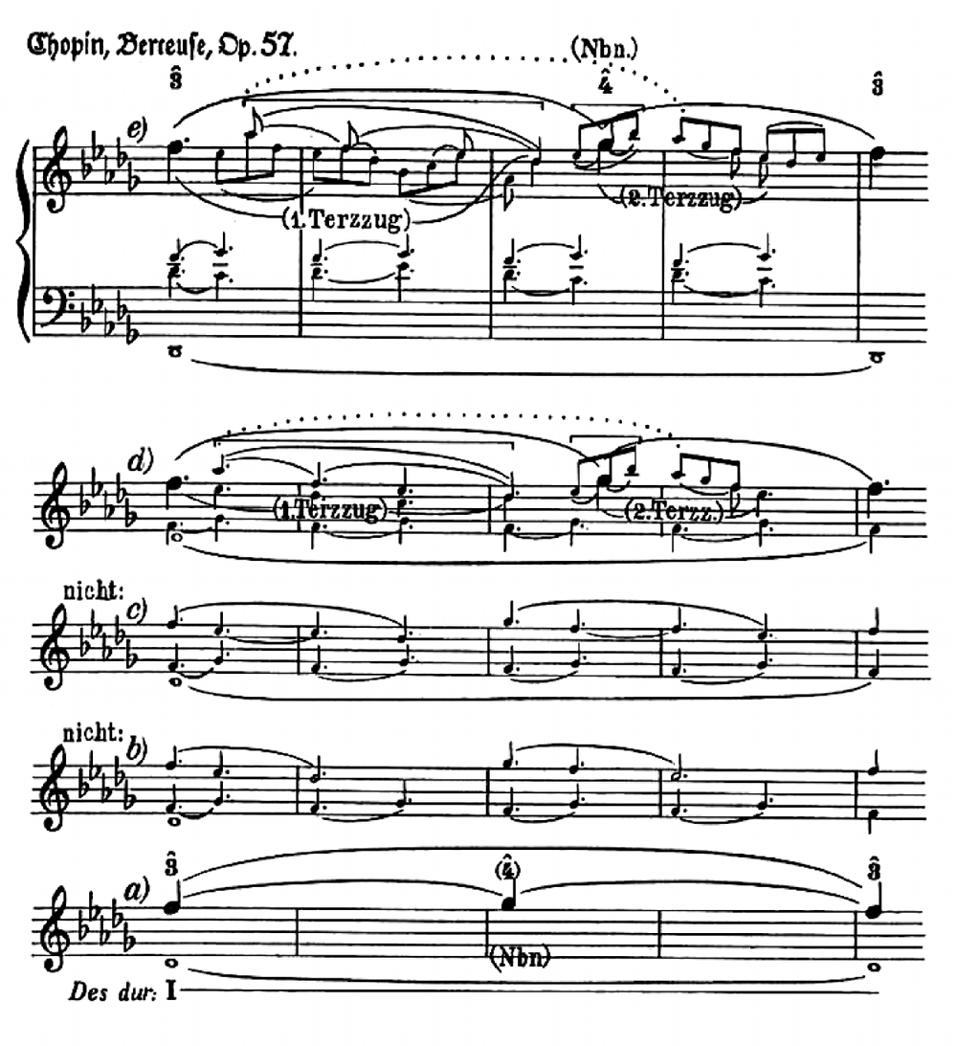

Example 3. First span and “echoing” span
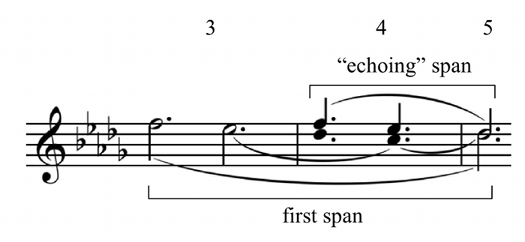

Example 4. Schenker’s Berceuse analysis simplified, with metrical analysis
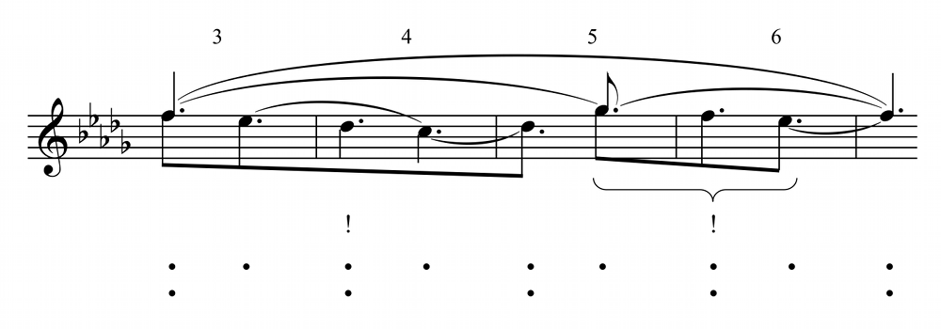

Example 5. Berceuse theme with neo-Schenkerian fingering
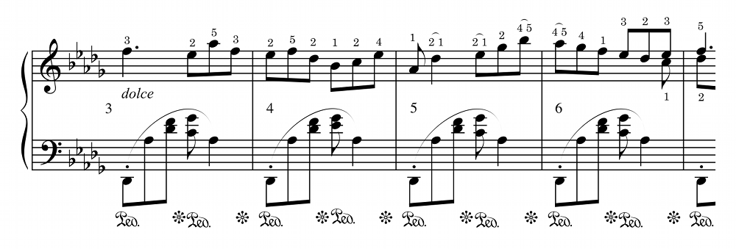
Example 6. Chopin Nocturne in E-flat major op. 9, no. 2, mm. 27–28
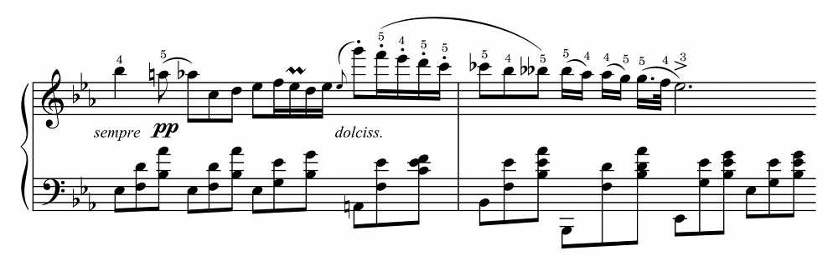

Example 7. Audible result of literally sustaining the F–G–F upper-neighbor motion
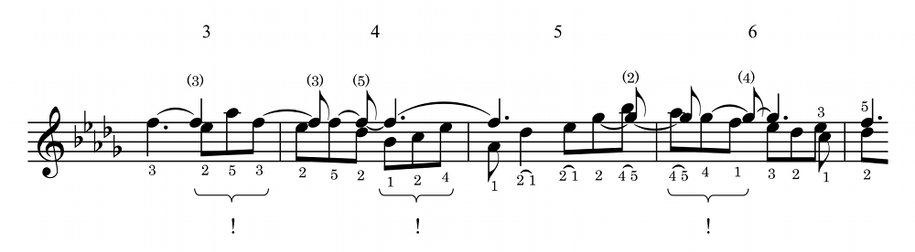
Example 8. Schumann, Melodie, from Album für die Jugend, op. 68, no. 1, mm. 1–4
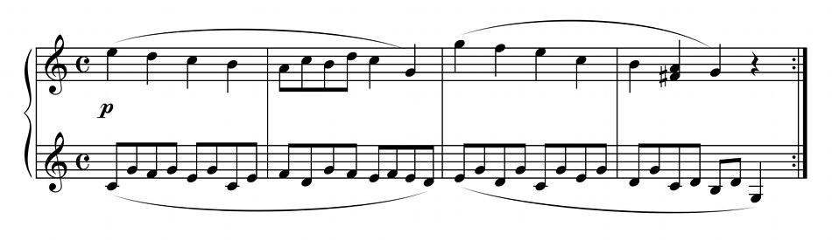

Example 9. Rings’s Zug networks
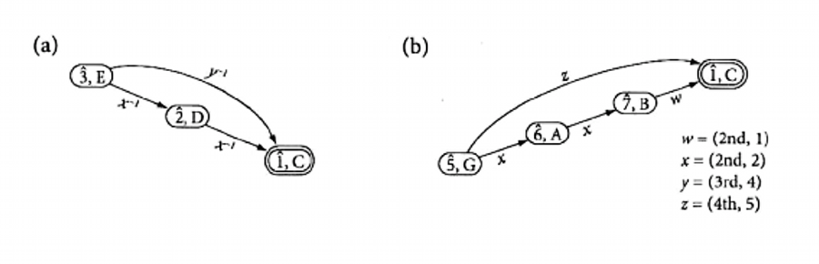

Example 10. Intentional structure of the fingering of Schumann’s Melodie, mm. 1–2
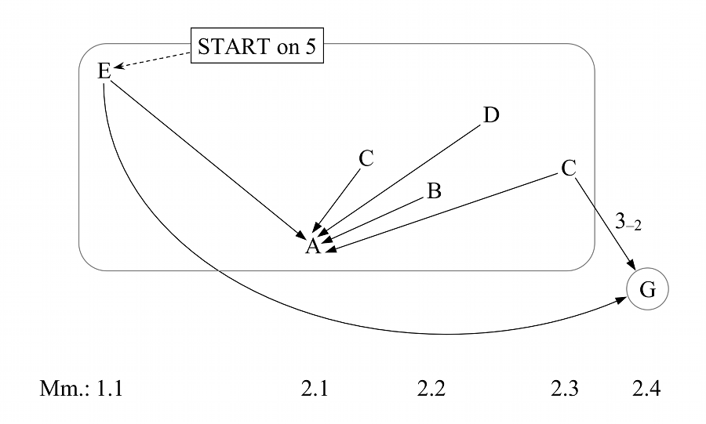

Example 11. Neo-Schenkerian fingering with annotated hand positions
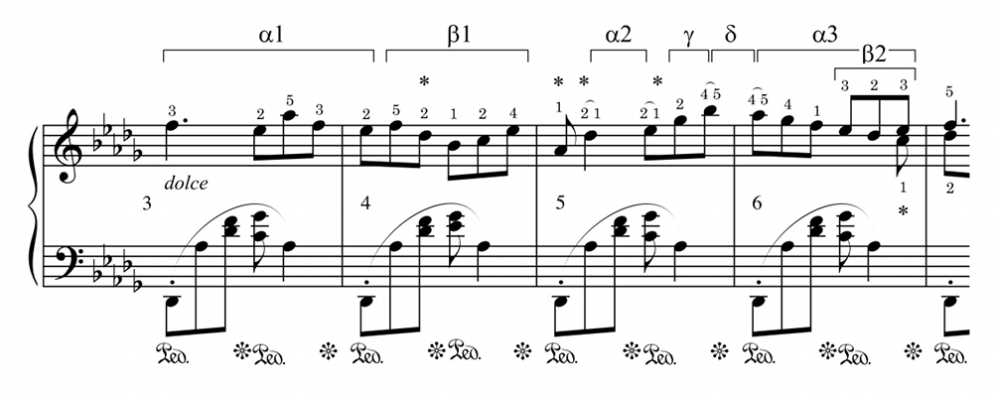

Example 12. Intentional structure of neo-Schenkerian fingering
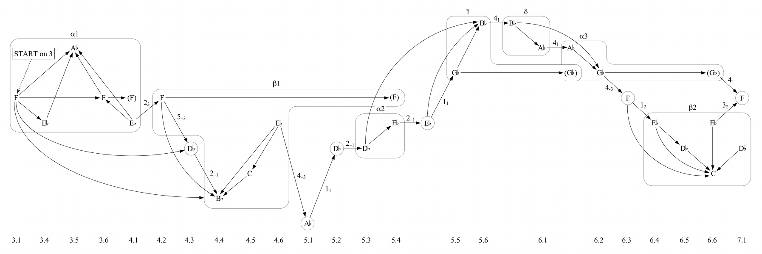

Example 13. Berceuse theme with Schenker’s fingering (mm. 1–10)
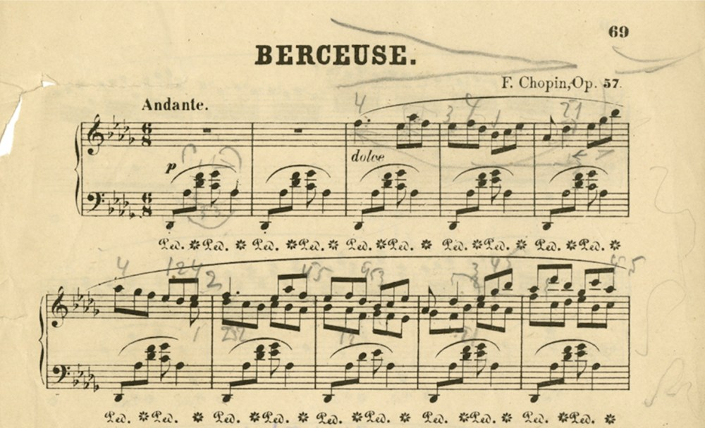

Example 14. Berceuse theme with Pugno’s (1902) fingering (mm. 1–10)
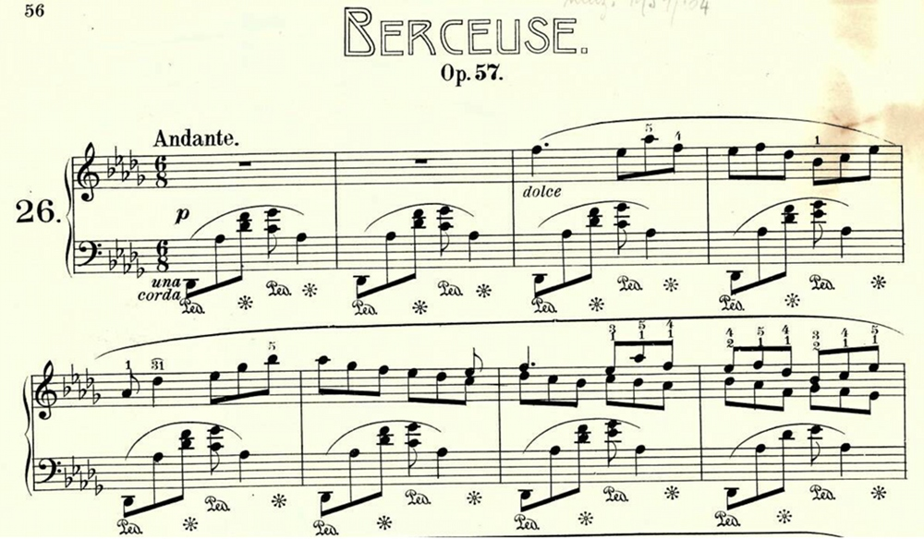

Example 15. Berceuse theme with Schenker’s fingering, including annotated hand positions
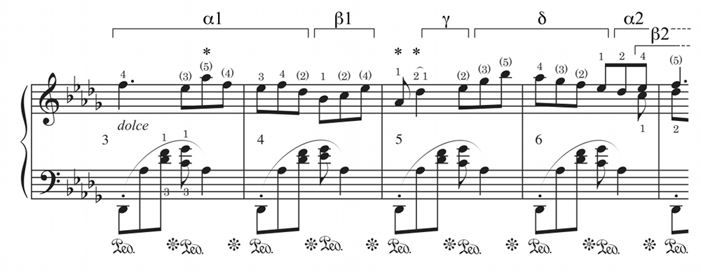

Example 16. Intentional structure of Schenker’s fingering of the Berceuse theme
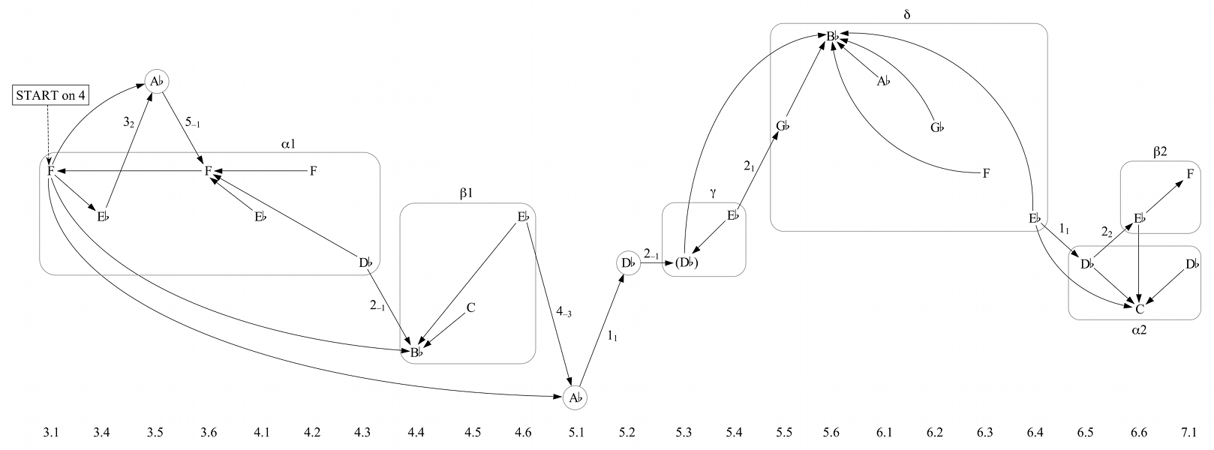

Example 17. Physical neighbor motion at a deeper structural level
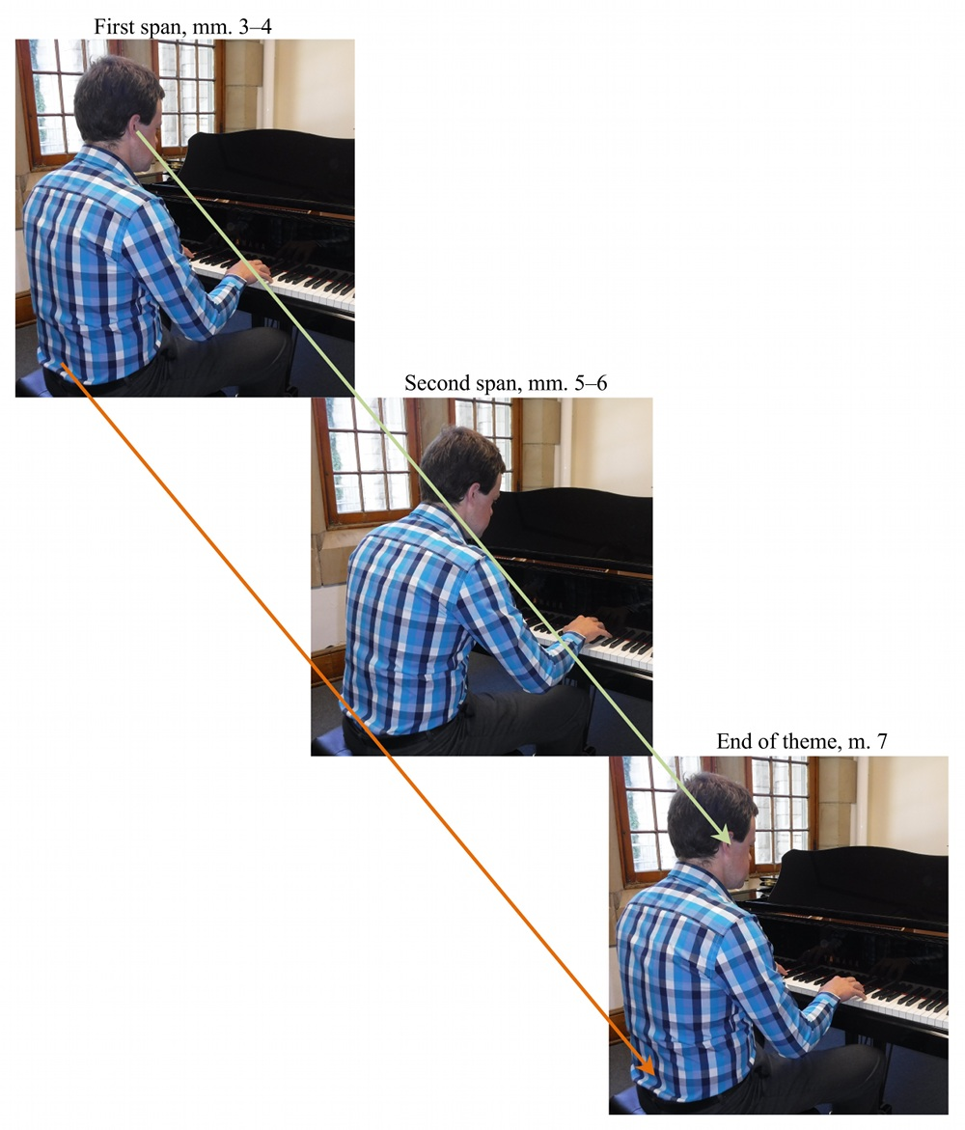

Example 18. Berceuse eight-measure variation to final cadence, mm. 55–70 (Measure numbers in italics and a Roman-numeral analysis have been added by the author)
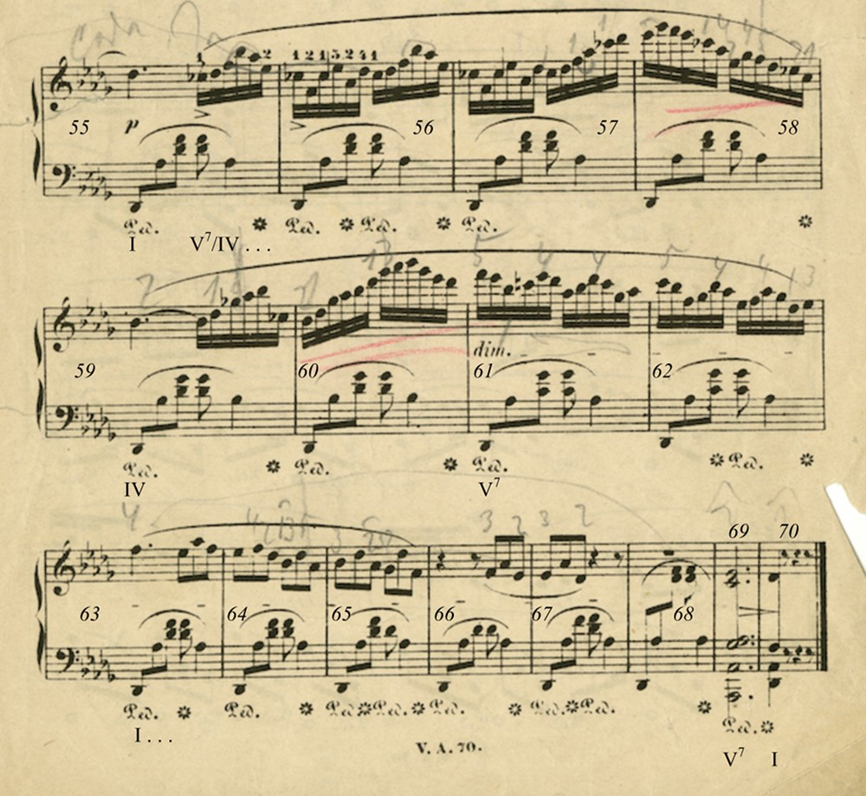

Example 19. Deep-middleground voice-leading diagram of the Berceuse
